Monthly Checklist for Dealership Parts Managers
If you count all your assets, you always show a profit.”

Week 1:

- Weekly meeting with Parts Team
- Review Parts sales goals against actual sales
- Ensure that freight and core charges are being collected
- Are freight charges growing?
- Housekeeping
- Ensure that parts are being received timely
- Check that parts are in the right location
- Identify obsolete/dead inventory
- Review bins (Missing/Misplaced items)
- Complete Cycle Counts
- Review Returned Parts statuses
- Review Inventory Turns by product line
- Check for price file updates from manufacturers and update in business system
- Set Sales prices and promotions

Week 3:

- Weekly meeting with Parts Team
- Review Parts sales goals against actual sales
- Ensure that freight and core charges are being collected
- Are freight charges growing?
- Run service productivity reports
- Housekeeping
- Ensure that parts are being received timely
- Check that parts are in the right location
- Identify obsolete/dead inventory
- Review bins (Missing/Misplaced items)
- Review Returned Parts statuses
- Review Inventory Turns by product line
- Check for price file updates from manufacturers and update in business system

Week 2:

- Weekly meeting with Parts Team
- Review Parts sales goals against actual sales
- Ensure that freight and core charges are being collected
- Are freight charges growing?
- Housekeeping
- Ensure that parts are being received timely
- Check that parts are in the right location
- Identify obsolete/dead inventory
- Review bins (Missing/Misplaced items)
- Complete Cycle Counts
- Review Inventory Turns by product line
- Check for price file updates from manufacturers and update in business system
- Review Returned Parts statuses
- Review Warranty-Defective parts and dispose of any older than 90 days
- Ensure dead stock is listed on online marketplaces

Week 4:

- Weekly meeting with Parts Team
- Review Parts sales goals against actual sales
- Ensure that freight and core charges are being collected
- Are freight charges growing?
- Housekeeping
- Ensure that parts are being received timely
- Check that parts are in the right location
- Identify obsolete/dead inventory
- Review bins (Missing/Misplaced items)
- Complete Cycle Counts
- Review Inventory Turns by product line
- Check for price file updates from manufacturers and update in business system
- Review Returned Parts statuses
- Review pending Special Orders
- Review Purchase Orders report
- Review Parts Gross Profit report
- Compare Parts Sales against budget
- Reconcile Inventory Value/WIP with the General Ledger

Daily:

- Monitor daily numbers in your dealer management system’s Parts Manager
- Parts Volume
- Parts Needed (Special Order Parts and Parts Below Re-order Point)
- Purchase Orders (Review expected date)
- Special Order/Back-Order Details (Review statuses)
- Run daily reports
- Parts Gross Profit
- Parts Sold by Counterperson
- Negative Parts
- Exceptions (Low Margin, Negative, Aged)
- Inventory Adjustments
- Review Special Order Requests from Service Department
- Review and Complete Parts Lookup and Ordering
- Review Order Statuses
- Parts Research
- Parts Ordering
- Parts Received
- Check if parts are being received in a timely manner
- Check that parts are in the correct location
- Compare Profit and Cashflow against your budget
- Make sure that customer-facing areas of free of clutter
- Ensure fronting and facing is complete for all parts displays
- Check all used Work Order items are returned to the Parts department
- Replenish empty parts bins from overstock
- Check text message inbox to address any unanswered customer conversations

Ready to boost productivity and efficiency at your dealership?
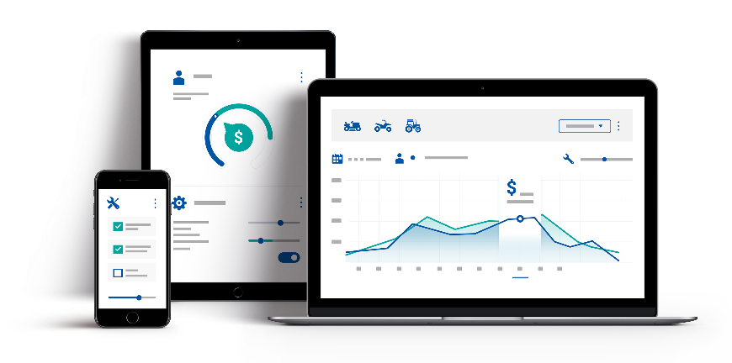

Charter Software Inc. partners with servicing dealers & distributors to promote mutual success through use of our technology-based management tools. ASPEN is an affordable, Microsoft-based Business Management System used by hundreds of equipment dealers across North America to better run their business and positively impact their bottom line.
Ready to learn more about Charter Software? Call us at 303-932-6875

